**IFT 466 Advanced Computer Networks**

**Lab 14  
EIGRP – IPv6**

After you complete each step, put a ‘√’ or ‘x’ in the completed box

**Objective**To successfully configure EIGRP for IPv6. To configure EIGRP for IPv6, we will carry out the four following steps

* We will configure IPv6 addresses on the routers
* We will enable EIGRP globally on all the routers
* We will then enable EIGRP on the interfaces
* We will verify EIGRP for IPv6 is configured

1. Setup the following topology in Packet Tracer

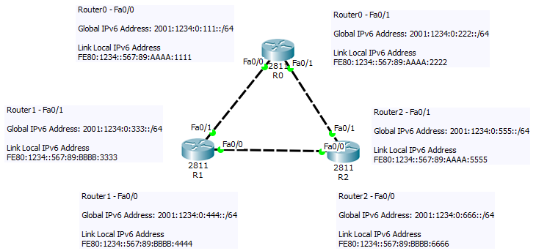



✓

1. Configure IP addresses on all 3 routers. R1 is shown below.

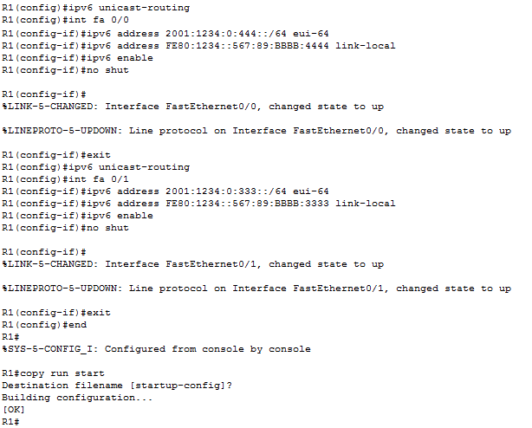  
 ✓

When you finish the configuration, all the interfaces will be up on R1.   
  
Now perform the same configuration on R0 and R2

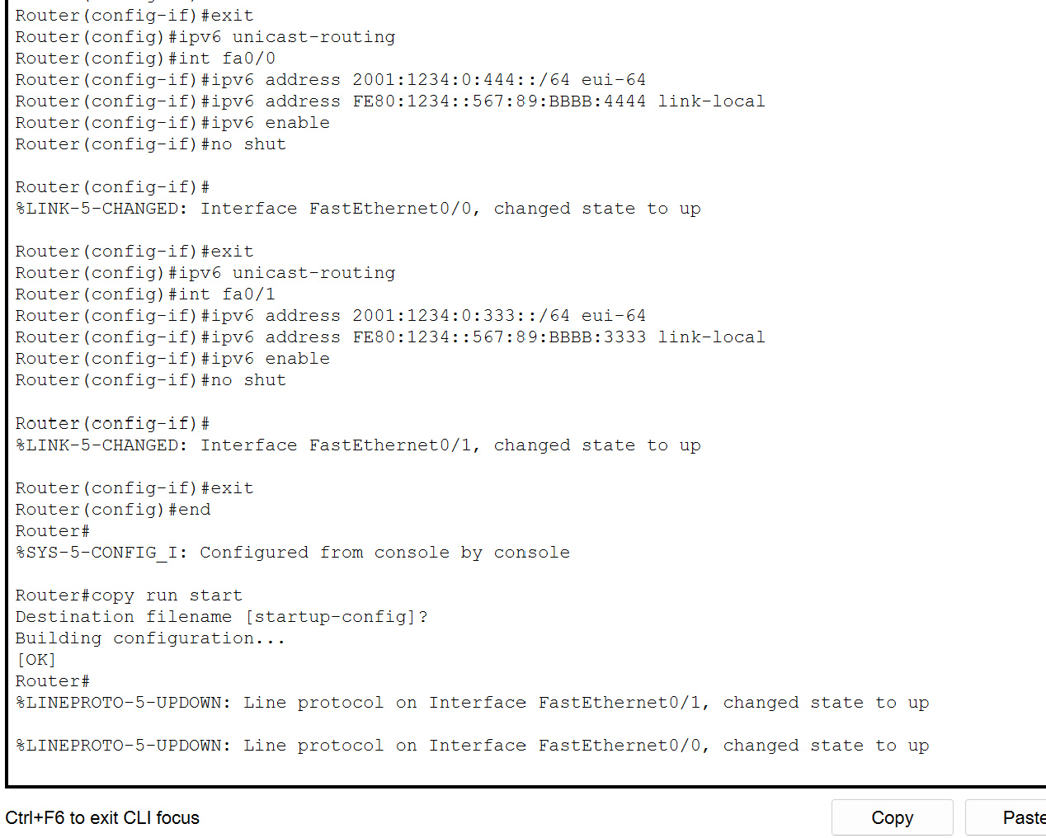

When you complete the configuration on R0/R2, the topology should look like the following image

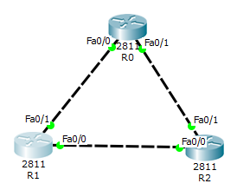

✓

1. Now we will configure EIGRP on interfaces and globally on the routers  
     
   We will start with R1

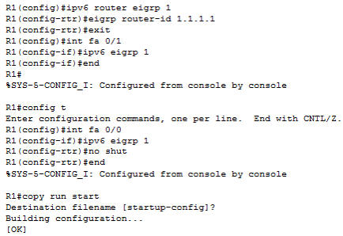



✓

1. Now repeat for R0 & R2



✓

1. You can now see the configuration via show run on r1

As you can see, EIGRP for IPv6 is here (red) & IPv6 configuration is under the interfaces (blue).

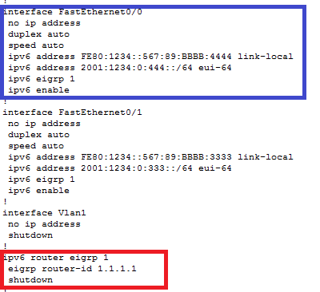

✓

1. Notice the neighbor adjacency pop up when we turn on EIGRP on R0

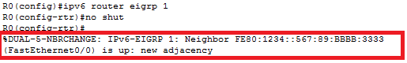

Same for R2

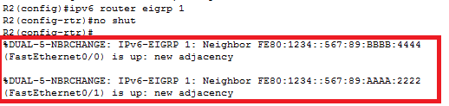

✓

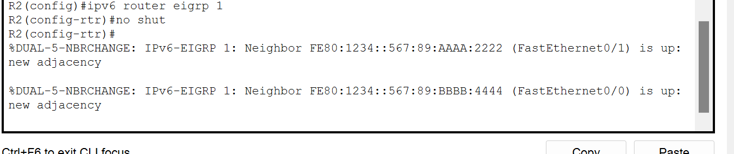

1. Lets now verify the EIGRP configuration on R1. As you can see, fa 0/0 and fa 0/1 are here

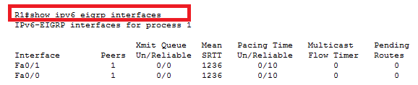

✓

1. Let check out the routes via the show ipv6 route

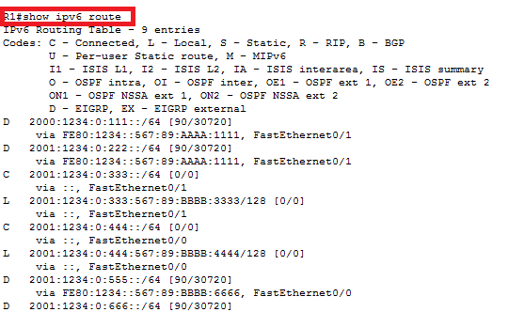

  
 ✓

1. Let’s check out more configurations via the 1) show ipv6 eigrp neighbors 2) show ipv6 eigrp topology and 3) show ipv6 eigrp traffic

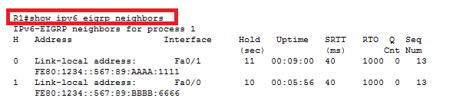

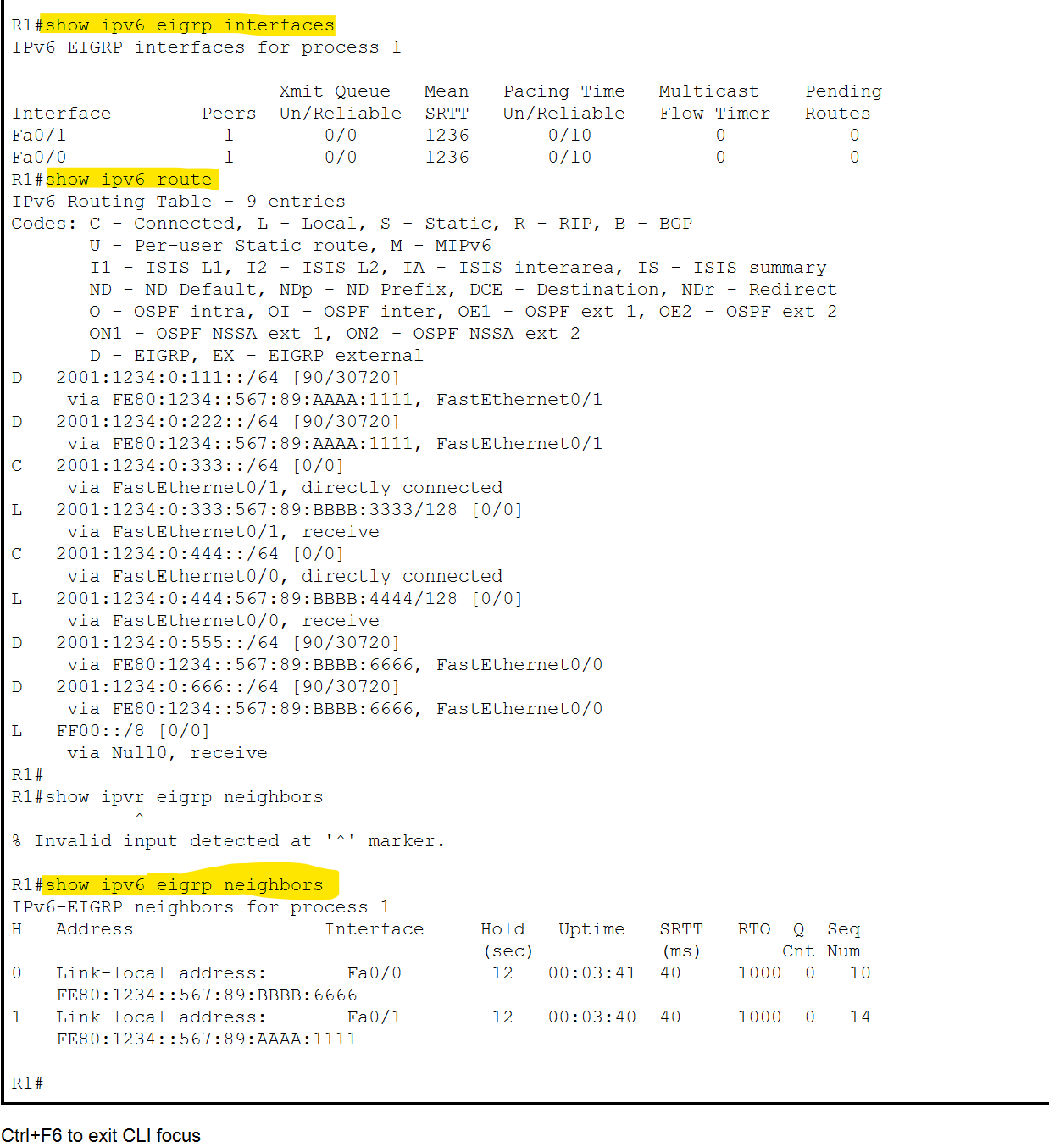

✓

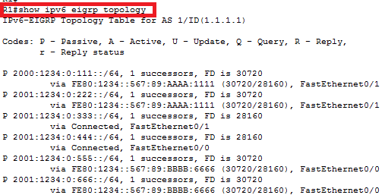

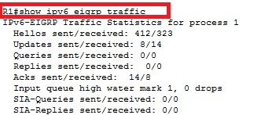



✓

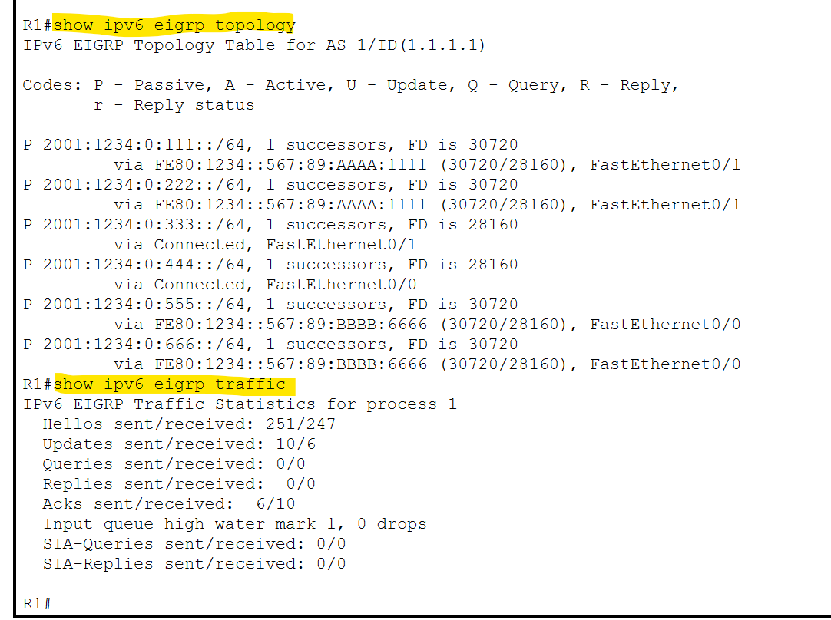

1. Let us verify by pinging the other routers. Ping R0 (fa 0/1) from R1



